

**EXPOSYS DATA LABS**

**BENGALURU-560064**

**An Internship Report**

On

**CUSTOMER SEGMENTATION**

*Submitted in partial fulfillment of the requirement for the award of the degree of*

**BACHELOR OF ENGINEERING**

in

**COMPUTER SCIENCE AND ENGINEERING**

*Submitted by*

**PALLAVI 1VE17CS078**

**RAUSHAN KUMAR 1VE17CS094**

**SHAHID GULZAR AHANGER 1VE17CS101**

**YUGAM PAHWA 1VE17CS126**

*Under the Guidance of*

**Mr. VISHNU**

HR

P.M R. Residency, Ground Floor, No-5/3 Sy. No.10/6-1 Opp Nithyotsava Wedding Hall, Doddaballapur Main

Road, Singanayakanahalli, Yelahanka, Bengaluru, Karnataka 560064

**DEPARTMENT OF COMPUTER SCIENCE AND ENGINEERING**

**(Accredited by NBA)**

**SRI VENKATESHWARA COLLEGE OF ENGINEERING,**

**BANGALORE - 562 157.**

**2020-2021**



**ABSTRACT**

This is to verify that the project entitled **“CUSTOMER SEGMENTATION” using DATA SCIENCE** carried out by **Ms.** PALLAVI**, USN** 1VE17CS078 ,**Mr.** RAUSHAN KUMAR**, USN** 1VE17CS094 , **Mr.** SHAHID GULZAR AHANGER**,** **USN** 1VE17CS101, **Mr.** YUGAM PAHWA**, USN** 1VE17CS126 are bonafide students of Sri Venkateshwara College of Engineering, in partial fulfillment for the award of Bachelor of Engineering in Computer Science and Engineering of **Visvesvaraya Technological University, Belgaum** during the academic year 2020-2021.

**Signature of the Guide**

**Mrs. VISHNU**

HR

EXPOSYS DATA LABS

**Table of Content**

**1. Introduction**

* 1. **Existing System** 
     + 1. **Methodology**
     1. **Implementation**

1. **Conclusion & Graphical User Interface**

**1**

**2**

**4**

**5**

**6**

Customer Segmentation

**CHAPTER 1**

**INTRODUCTION**

The purpose of the project is to build an application program to identify the several segments of customers allowing them to target the potential user base. It provides all the details of the different section of customer and fetch the information . Customer Segmentation is a popular application of unsupervised learning. Using clustering, identify segments of customers to target the potential user base. They divide customers into groups according to common characteristics like gender, age, interests, and spending habits so they can market to each group effectively.

**1.1 OBJECTIVES**

* The main objective of the project is to design and develop a user friendly system.
* Easy to use and an efficient computerized system.
* To develop an accurate and flexible system, it will eliminate data redundancy.
* To study the functioning of Customer Segmentation.
* To make a software fast in processing, with good user interface.
* To make software with good user interface so that user can change it and it should be used for a long time without error and maintenance.
* To provide synchronized and centralized Customer Segmentation System.
* Computerization can be helpful as a means of saving time and money.
* To provide better Graphical User Interface (GUI).
* To provide immediate storage and retrieval of data and information.

Pg. 1

Customer Segmentation

**CHAPTER 2**

**EXISTING SYSTEM**

**2.1** **CUSTOMER SEGMENTATION**

Customer Segmentation is a browser based system that is designed to store, process, retrieve and analyse information concerned with the various sections and information related pages like-name, age, address, phone no.

Customer Segmentation is available to everyone easily on website. Customer Segmentation is a system to assist companies in achieving “best information regarding the customer”. It is used to manage resources, increase information yield, reduce complexity to get knowledge regarding services provided by the Customer Segmentation.

**TECHNICAL FEASIBILITY**

1. The technical issue usually raised during the feasibility stage of the investigation includes the following:
2. Does the necessary technology exist to do what is suggested?
3. Do the proposed equipment have the technical capacity to hold the data required to use the Customer Segmentation system?
4. Will the proposed system provide adequate information to inquiries, regardless of the number or location of users?
5. Can the system be upgraded if developed?
6. Are there technical guarantees of accuracy, reliability, ease of access and data security?

Pg. 2

Customer Segmentation

**2.2 PROPOSED METHOD**

Customer Segmentation is a popular application of unsupervised learning. Using clustering, identify segments of customers to target the potential user base. They divide customers into groups according to common characteristics like gender, age, interests, and spending habits so they can market to each group effectively. K-means clustering and we visualize the gender and age distributions. We also analyse their annual incomes and spending scores.

The architecture used in customer Segmentation are seaborn, matplotlib for visualization, machine learning for modelling and pandas for Data analysis.

Pg. 3

Customer Segmentation

**CHAPTER 3**

**Methodology**

**3.1 SPECIFICATION**

The Software Requirements Specification is priced at the culmination of the analysis . The function and performance allocated to software as put of system are refined by establishing in complete information description , a detailed functional and behavioral description , an indication of performance , requirements and design constraints appropriate validation criteria other to requirements

The Method was of using various new tech to make website as responsive and as efficient possible

Technology Used: python

Framework Used: Jupyter notebook

Libraries Used: matplotlib, seaborn, pandas

Icons used: vector icons

Pg. 4

Customer Segmentation

**CHAPTER 4**

**Implementation**

**4.1 SOFTWARE REQUIREMENTS:**

1. Operating System: Windows 7 or higher
2. Browser: Google Chrome/Internet Explorer

**4.2 HARDWARE REQUIREMENTS:**

1. Computer with a 1.1 GHz or faster processor
2. Minimum 4GB of DDR3 RAM or more
3. 2.5 GB of available hard-disk space
4. 5400 RPM hard drive
5. 600*800 or higher-resolution display

The implementation of this kind of website couldn’t be more simpler .The user just have to visit the URL “[www.exposysdata.com](http://www.exposysdata.com/)” to get full fledged experience and knowledge about data science internship.

Pg. 5

Customer Segmentation

**CHAPTER 5**

**CONCLUSION & SHOTS OF USER INTERFACE**

Customer Segmentation is the process of division of customer base into several groups of individuals that share a similarity in different ways that are relevant to marketing such as gender, age, interests, and miscellaneous spending habits.

Companies that deploy customer segmentation are under the notion that every customer has different requirements and require a specific marketing effort to address them appropriately.

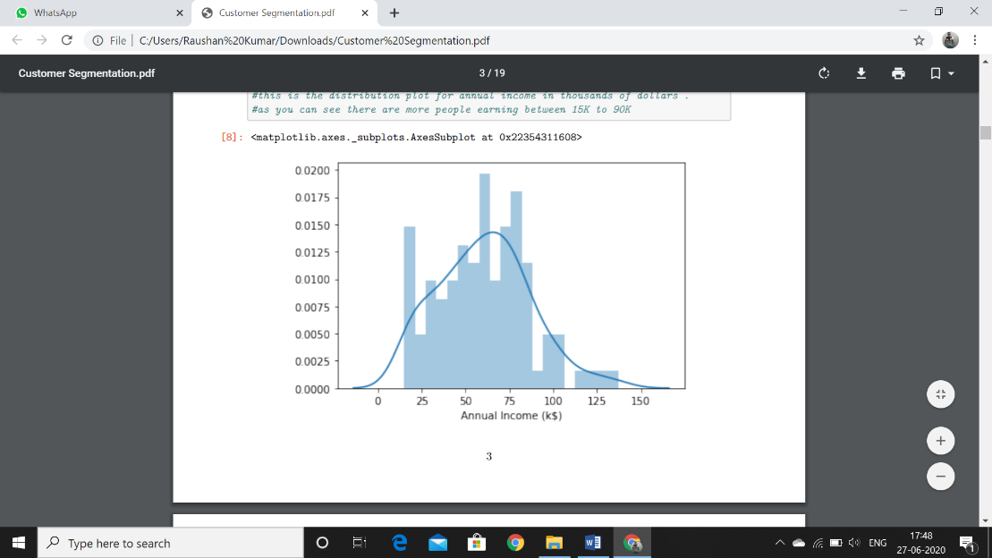

Pg. 6

Customer Segmentation



Pg. 7

Customer Segmentation

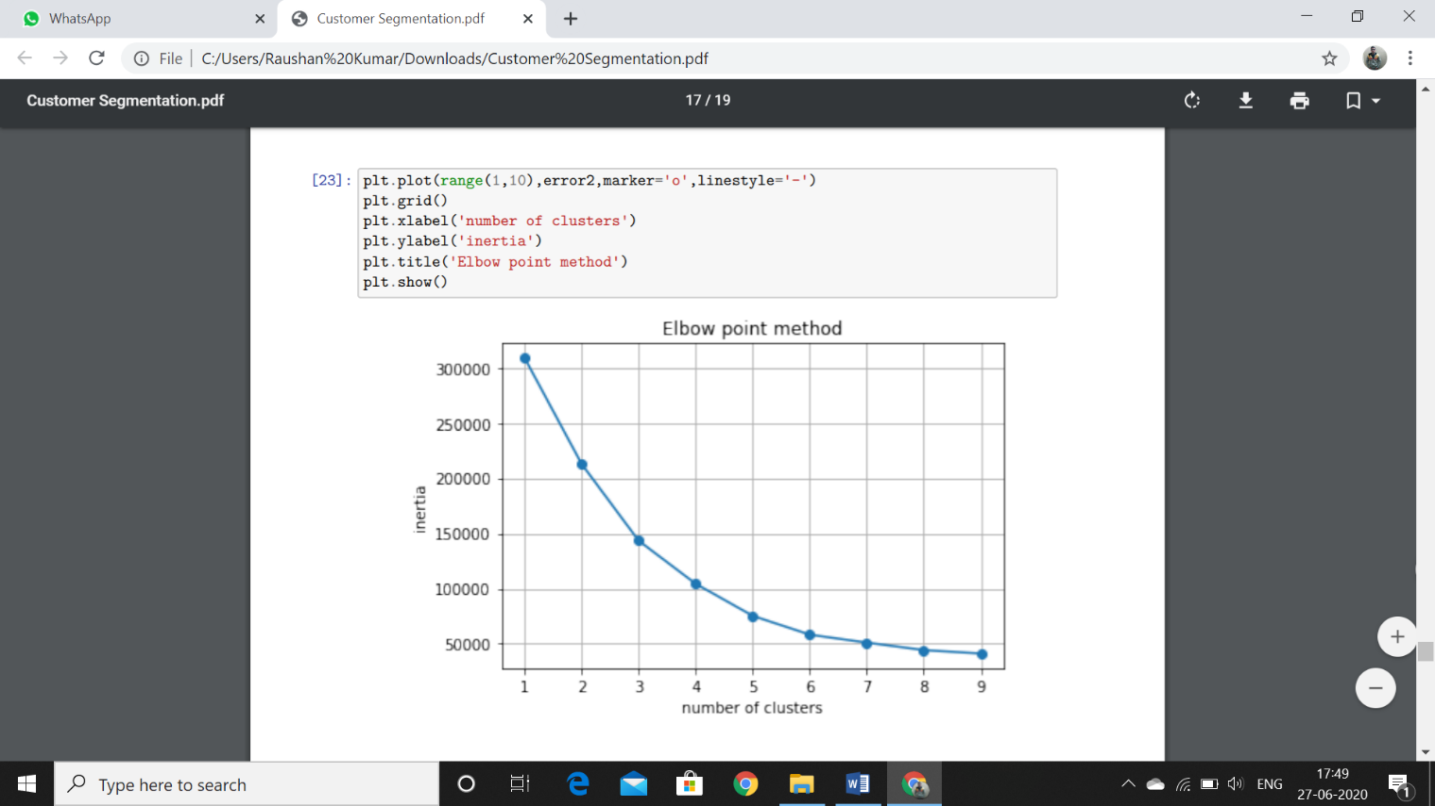

Pg. 8